Assignment 4

Task 1: Encrypt a Column

1. Using the SSMS GUI, configure the **phone** row of the **salesapp1.Sales.Customers** table to be encrypted using Always Encrypted.

2. Run a SELECT statement against the **salesapp1.Sales.Customers** table to view the encrypted data.

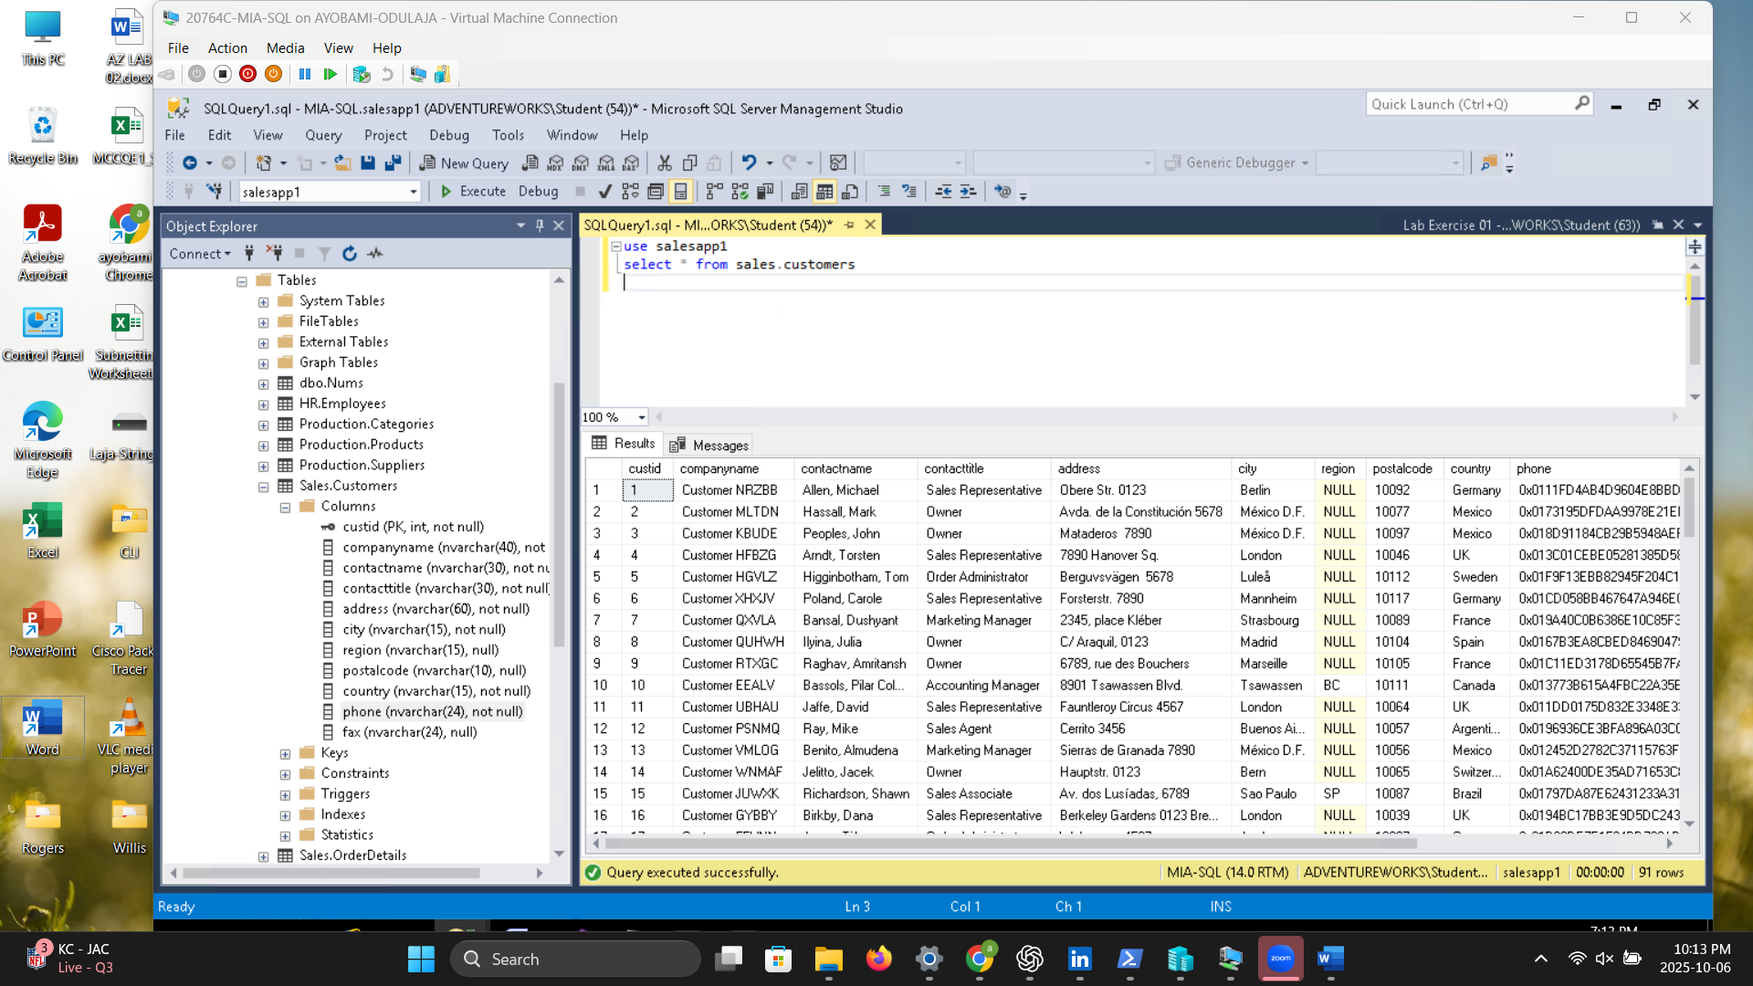

1. Using the SQL Server Management Studio (SSMS) GUI, create a server audit with the following

properties:

o **Name**: activity_audit

o **Queue delay**: 1000 ms

o **On failure**: continue

o **Target**: file

o **Target file path**: D:\Labfiles\Lab04\Starter\Audit

2. Enable the server audit you have created.

